**Onedrive Guide**

**How to integrate Onedrive within Edge Connect**

Here's how:

You have to login in your Onedrive account, right-click on the file or folder you are interested in share, and choose Embed.

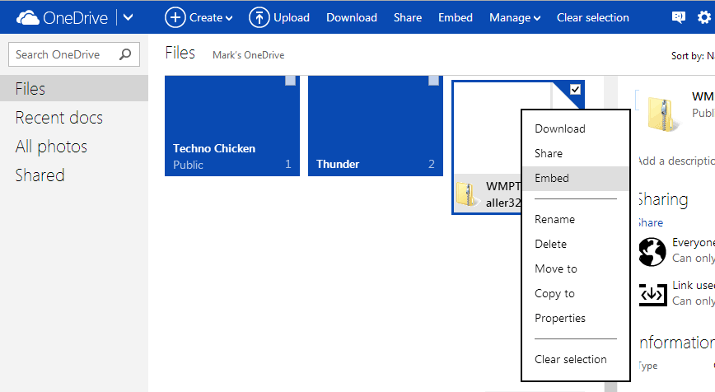

This will bring up the Embed pop-up.

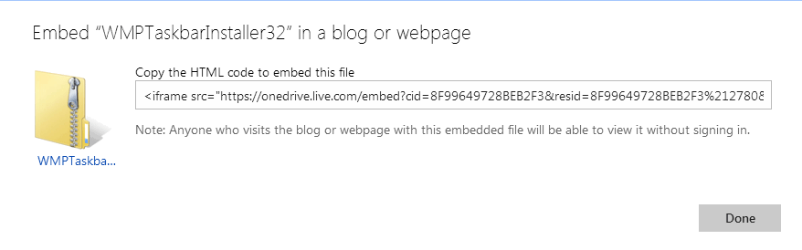

Select and copy on clipboard the embed HTML code. Now in Edge Connect application , select the phase where you want to add the One drive embed and insert a new display Item of text type in the Presentation Editor. Paste the embed HTML code in “text to be displayed” textarea. ( see the below image )

